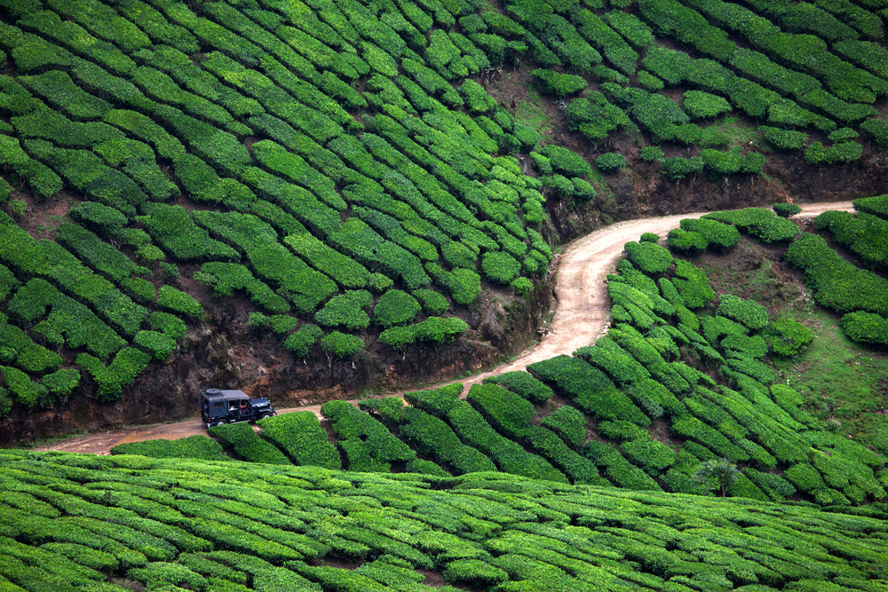
GOD’S OWN COUNTRY - KERELA

Circuit: Cochin – Munnar – Periyar – Alleppey – Kumarakom – Kovalam
ITINERARY:
DAY 01: | 16 MAR’26 | ARRIVAL COCHIN
Meeting and assistance upon arrival at Cochin International Airport and transfer to the hotel. Upon arrival, check in at the hotel in Cochin.

Rest of the day at leisure / explore surrounding

Overnight stay at a hotel in Cochin

DAY 02: | 17 MAR’26 | COCHIN – MUNNAR (127Kms, 4Hrs)
Morning after breakfast proceed for sightseeing tour of Cochin visiting the Dutch Palace, which has some of India’s most beautiful murals, the Jewish Synagogue in the heart of Jew Town and the cantilevered Chinese fishing nets. See St. Francis Church where Vasco da Gama was originally buried, and the Santa Cruz Church with its pastel coloured interior and carved wooden panels.

Later, drive to Munar. Upon arrival, check in at the hotel in Munar.

Rest of the day free for relaxation / explore surrounding

Overnight stay at a hotel in Munnar.
DAY 03: | 18 MAR’26| MUNNAR
Morning after breakfast, proceed for sightseeing tour of Munar
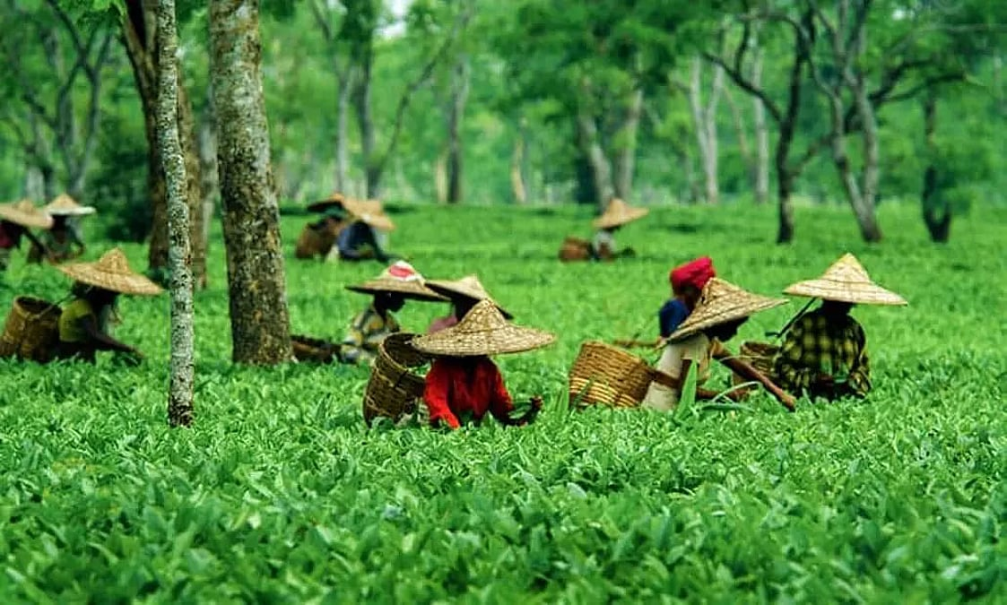
Tea Plantations: A visit to Munnar's tea plantations offers a fascinating insight into Kerala's rich tea tradition, nestled amid breathtaking natural beauty. Rolling hills covered with lush emerald-green tea gardens create a serene landscape, enhanced by fresh mountain air and panoramic views. Guided walks through the estates reveal the art and science of tea cultivation, from harvesting the tender leaves to understanding traditional and modern processing methods. The experience is further enriched by encounters with plantation workers and visits to tea factories, where the journey of tea, from leaf to cup, comes to life. A tea plantation tour in Munnar is a refined combination of nature, culture, and craftsmanship, leaving visitors with lasting memories and a deeper appreciation for one of India's finest teas.

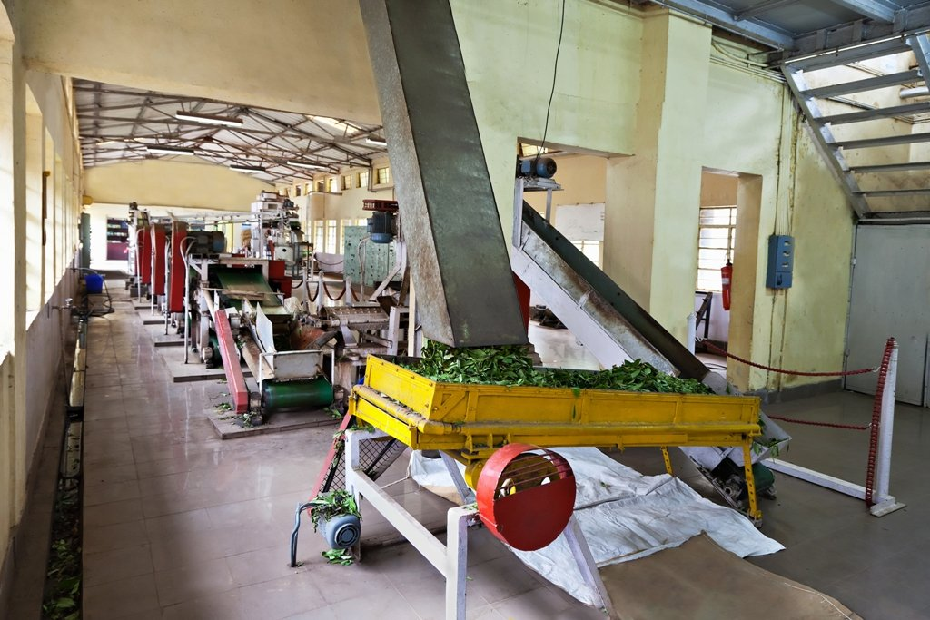
Tea Museum: The Munnar Tea Museum offers an engaging and informative journey through the history of tea cultivation in the Western Ghats. Through vintage photographs, original machinery, and detailed exhibits, the museum traces the evolution of the region's tea industry over the decades. Visitors can delve into the traditional processing techniques and modern innovations that have helped make Munnar a leading tea destination. A tasting of freshly brewed teas completes the experience, making a visit to the Tea Museum a refined and enriching experience that combines history, knowledge, and flavors.

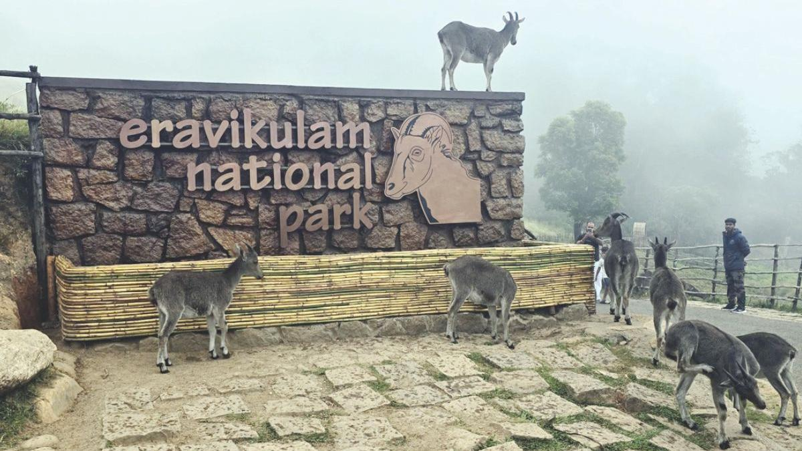
Eravikulam National Park, located near Munnar, is a pristine sanctuary renowned for its rich biodiversity and breathtaking high-altitude landscapes. Home to the endangered Nilgiri tahr, the park features rolling hills covered in grasslands, shola forests, and panoramic views of the Western Ghats. Well-maintained trails and lookouts allow visitors to admire the park's natural beauty and learn about its unique ecology and conservation efforts. During the blooming of the rare Neelakurinji, which blooms once every twelve years, the park transforms into a spectacular blue carpet. A visit to Eravikulam National Park offers an unforgettable experience, a perfect blend of wildlife, nature, and eco-friendly tourism.

Overnight stay at hotel in Munnar.

DAY 04: | 19 MAR’26| MUNNAR – PERIYAR (85Km, 03Hrs)
Morning after breakfast drive to Periyar. Upon arrival check in at hotel in Periyar.

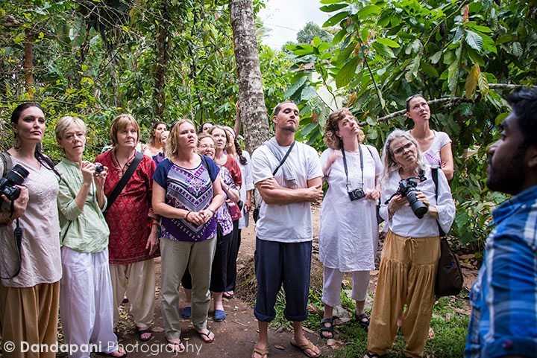
Afternoon proceed for Spice Plantations: It offers an immersive experience into the world of spices that made this land famous across the globe. Spread across scenic regions like Munnar, Thekkady, and Wayanad, these plantations are not just farms—they are living museums of Kerala’s agricultural heritage. Stroll through aromatic gardens of cardamom, pepper, vanilla, clove, cinnamon, and nutmeg, while learning their cultivation secrets. Visitors can enjoy guided tours, spice processing demonstrations, and even traditional Kerala meals flavored with these spices. A trip here is a sensory journey blending nature, history, and gastronomy.

Overnight stay at a hotel in Periyar.
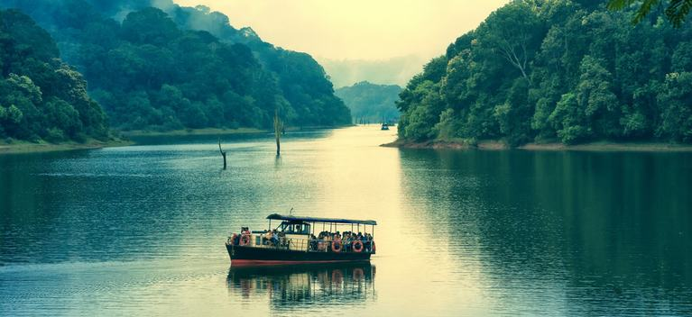
DAY 05: | 20 MAR’26| PERIYAR – ALLEPPEY (129KMS, 03HRS)
Morning after breakfast proceed for boat ride on Lake Periya. Periyar is South India’s most popular wildlife sanctuary, encompassing an area of 777 sq. km. Set on the attractive man-made Periyar Lake, it attracts over 300,000 visitors a year. Though the sanctuary was made a part of Project Tiger in 1973, it is better known for its elephants.

Later drive to jetty point to board houseboat. Upon arrival check in at houseboat

Lunch, Dinner & Overnight stay on Houseboat

DAY 06: | 21 MAR’26| ALLEPPEY – KUMARAKOM (32Kms, 57MNTS)
Morning after breakfast check out from houseboat and drive to Kumarakom. Upon arrival check in at hotel in Kumarakom.

Rest of the day free for relaxation / explore surrounding

Overnight stay at a Kumarakom hotel.

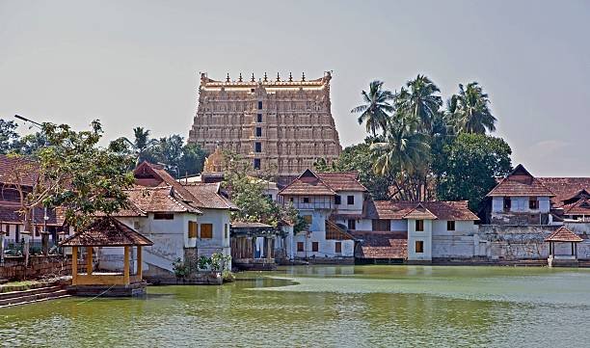
DAY 07: | 22 FEB’26| KUMARAKOM – KOVALAM (176Kms, 04Hrs)
Morning after breakfast drive to Kovalam. Afternoon proceed for sightseeing tour of Trivandrum visiting the 260 year old Padmanabha Swami Temple (non-Hindus cannot enter), Napier Museum, Sri Chitra Art Gallery (both are closed on Mon/Wed mornings), the Zoological gardens and Reptile House, and the Observatory. Also visit Kanakakunnu Palace, which is a gracious building in the Indo-Saracenic style famous for the stuccowork on its domes and arches.

Overnight stay at a hotel in Kovalam.
DAY 08: | 23 MAR’26| KOVALAM – KANYAKUMARI – KOVALAM (77Kms, 02Hrs ONE WAY DRIVE)

Morning after breakfast proceed for same day exursion to Kanyakumari: Kanyakumari, the southernmost point of mainland India, lies at the confluence of the Indian Ocean, the Arabian Sea and the Bay of Bengal. It is basically a pilgrimage town dedicated to the virgin Goddess Devi Kanya whose temple overlooks the shoreline. On a rock about 500 m offshore stands the Vivekananda Memorial, dedicated to Swami Vivekananda, a great Indian philosopher. The construction reflects architectural styles from all over India. Kanyakumari is the only place in India where one can watch the sunset and the moonrise simultaneously on a full moon evening.

Later return to Kanyakumari.

Overnight stay at a hotel in Kovalam.
DAY 09: | 24 MAR’26| DEPART KOVALAM
On time transfer to Trivandrum Airport to board flight for the onward destination.

TOUR COST
CATEGORY | COST PER PERSON
Total cost based on 4 star hotel for six paying pax | INR 46600 PP

City | Hotel | Date | Night
Cochin | Gokulam Park or similar | 16 – 17 Mar’26 | 01
Munnar | Silver Tips or similar | 17 – 19 Mar’26 | 02
Periyar | Peppervine or similar | 19 – 20 Mar’26 | 01
Alleppey | Premium Houseboat | 20 – 21 Mar’26 | 01
Kumarakom | Lake Song or similar | 21 – 22 Mar’26 | 01
Kovalam | Aadishakti Leisure Resort or similar | 22 – 24 Mar’26 | 02
Total number of nights |  |  | 08 Nights

Our prices include:

Price per person in a double room.

Bed and breakfast at all places excepto n Houseboat on Full Board basis (Breakfast, Lunch, Dinner).

Transfers as per itinerary by using Air-Conditioned Tempo Traveler.

Spice plantation tour

Cruise in the backwater of Vembanad Lake in Alleppey.

Boat ride on Periyar Lake

1 night in Cochin with bed and breakfast.

2 nights in Munar with bed and breakfast.

1 night in Periyar with bed and breakfast.

1 night in Alleppey on Premium Houseboat on all meals (Breakfast, Lunch, Dinner).

1 night in Kumarakom with bed and breakfast.

2 nights in Kovalam with bed and breakfast.

Sightseeing tours and entrance fees as per itinerary.

Local English-speaking guide in Cochin, Munnar, Trivandrum, and Kanyakumari excursion as per the program.

Government tax (5%).

Our prices do not include:

Beverages.

Any services not mentioned as included, including personal extras such as telephone calls, laundry service, etc.

Entry visa. Visas can be obtained online at: www.indianvisaonline.gov.in

Tips for guides (at the client's discretion).

Travel and cancellation insurance (optional).

